[FromQuery] - Gets values from the query string.

[FromRoute] - Gets values from route data.

[FromForm] - Gets values from posted form fields.

[FromBody] - Gets values from the request body.

[FromHeader] - Gets values from HTTP headers.

[FromServices]

Code First Approach

Add-Migration

Database-Update

------------------------------------

DataFirst Approach

1)Scaffold-DBContext "Name=ConnectionStrings:DefaultConnection" Microsoft.EntityFrameworkCore.SqlServer

or

Scaffold-DBContext "Name=ConnectionStrings:DefaultConnection" Microsoft.EntityFrameworkCore.SqlServer -OutputDir Models -ContextDir Data

Scaffold-DBContext "Name=ConnectionStrings:DefaultConnection" Microsoft.EntityFrameworkCore.SqlServer -OutputDir Models -ContextDir Data -Force

Partial class

Entity Framework (EF) requires each entity that you add or track to have a primary key.

The key helps EF know whether the object is new or existing in the database.

Keyless entities cannot be added or updated, only queried.

If you’re calling .Add() or .AddAsync() on it, you must have a key.

Repository

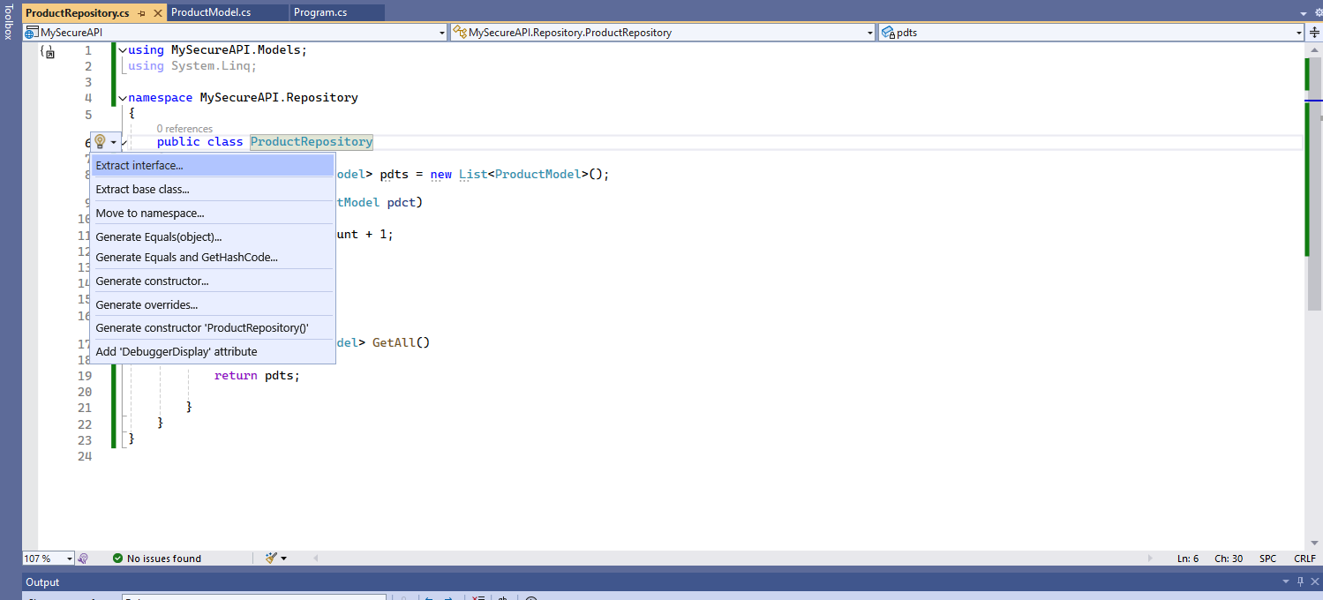

Interface

Product Model

ProductsController

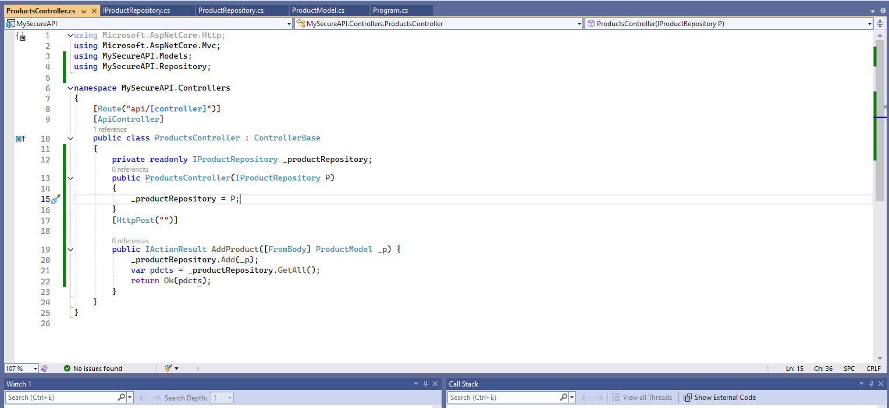

In Startup.cs (In new version its in program.cs) -DI-Singleton ---

So in controller we are not adding each time **new** Repository, we are just assigning Interface.

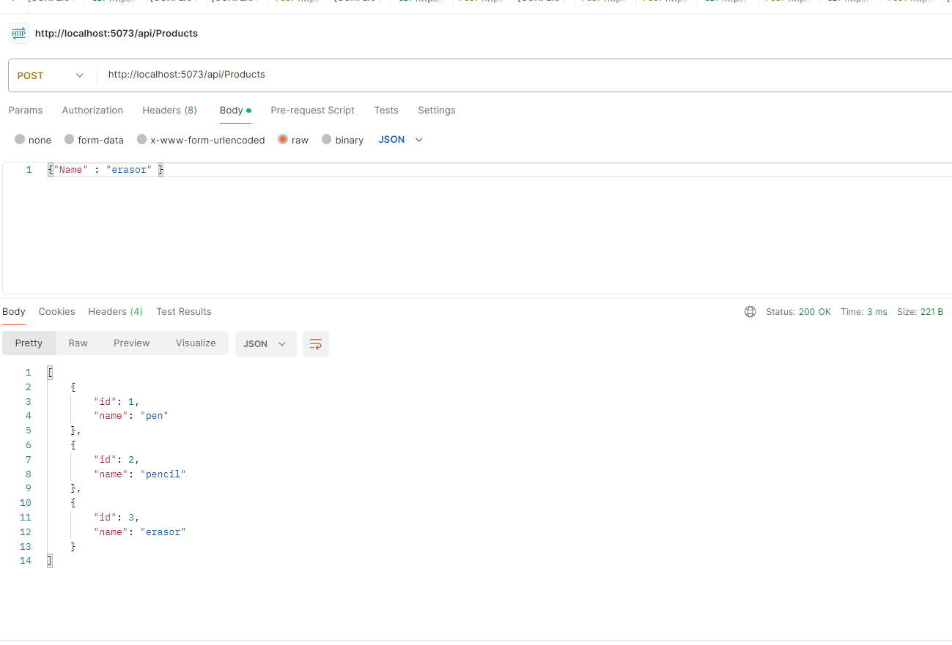

Each time we call this url, each product get added – its appending to existing product list. Singleton- 1 instance through out.

Scoped Service

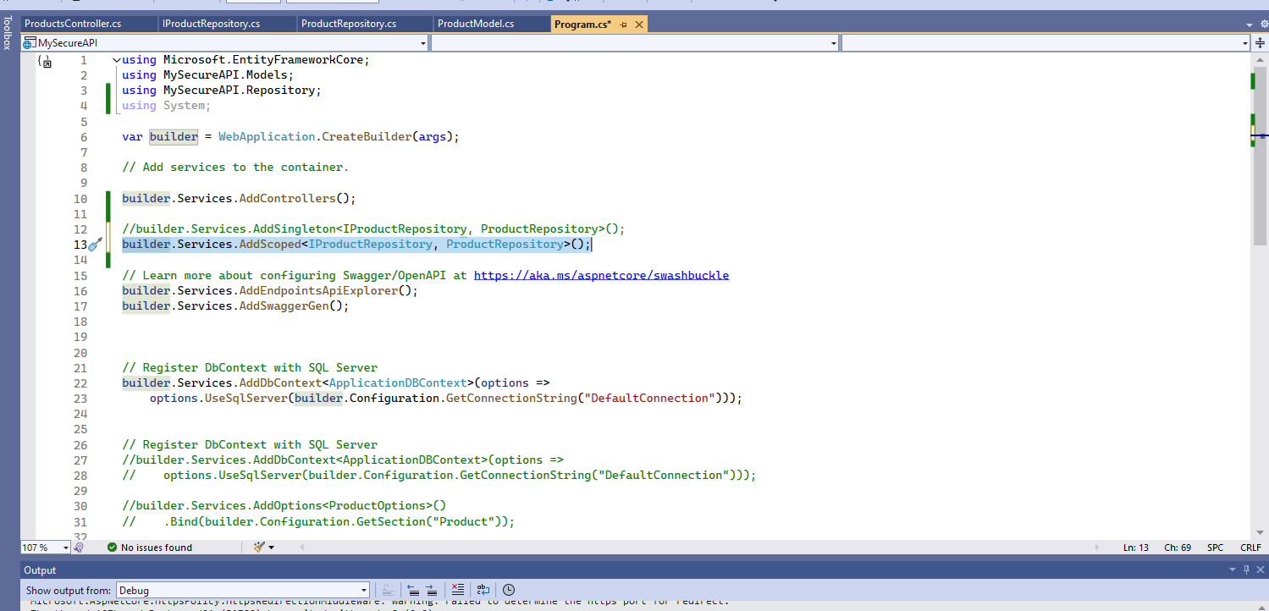

Each time, url refresh, add item its id becoming 1 because fresh product list.

Add Transient method

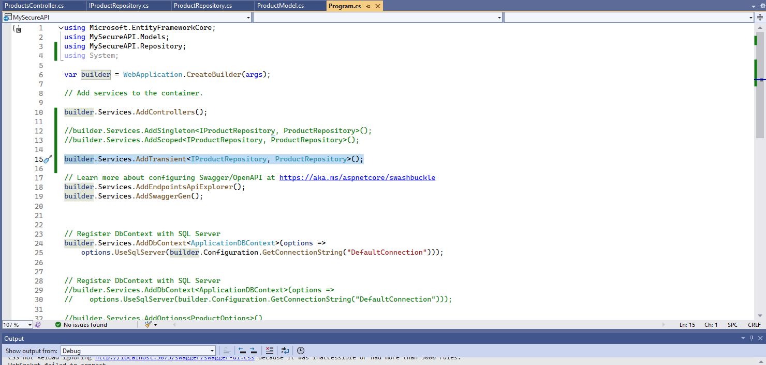

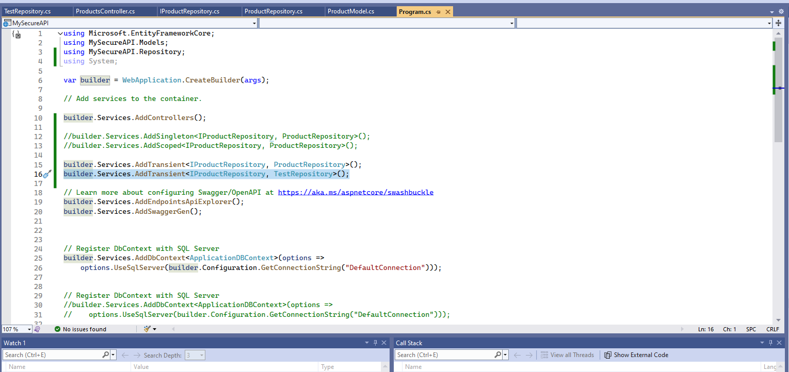

TryAddTransient

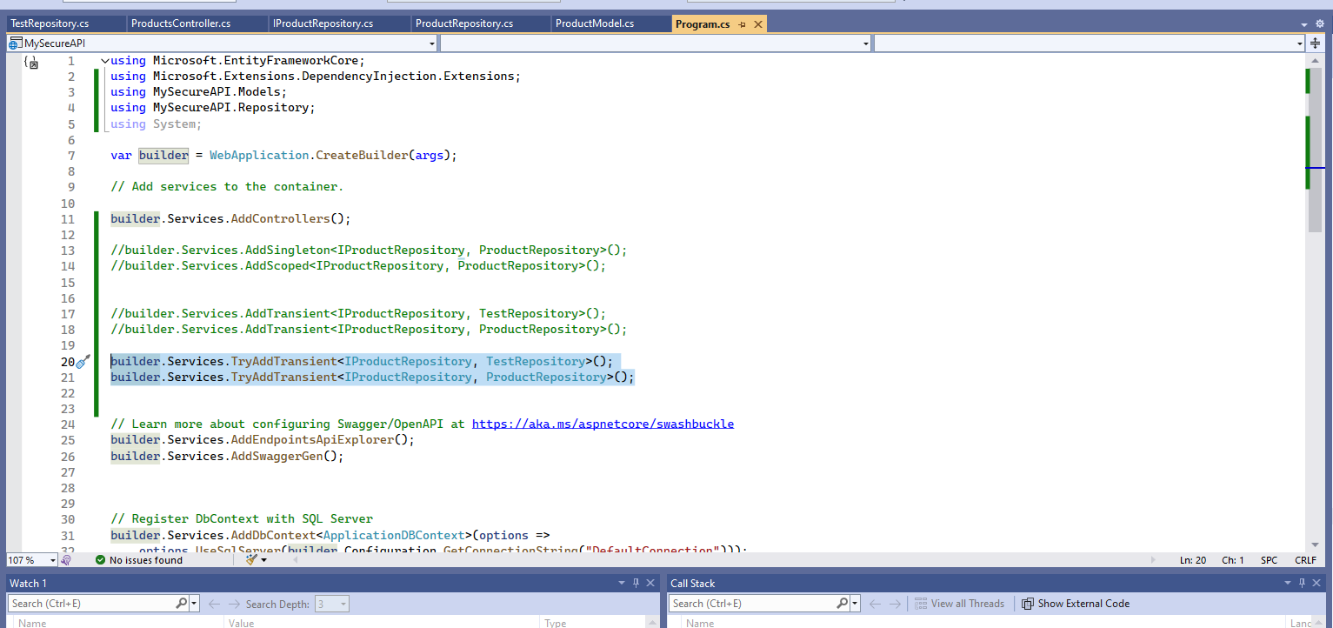

From Services Attribute

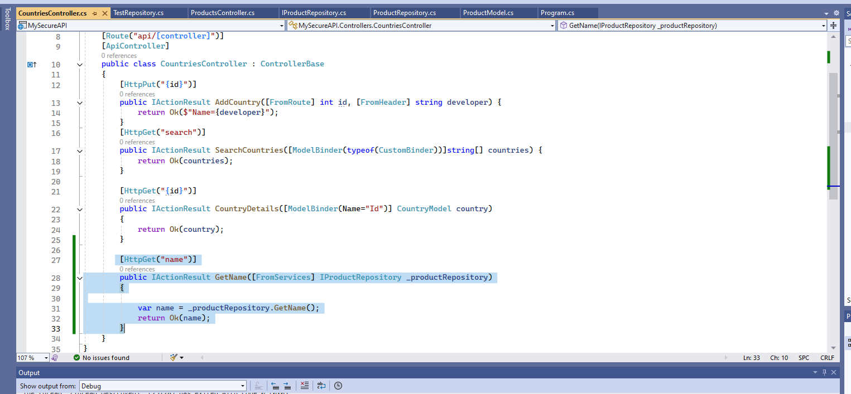

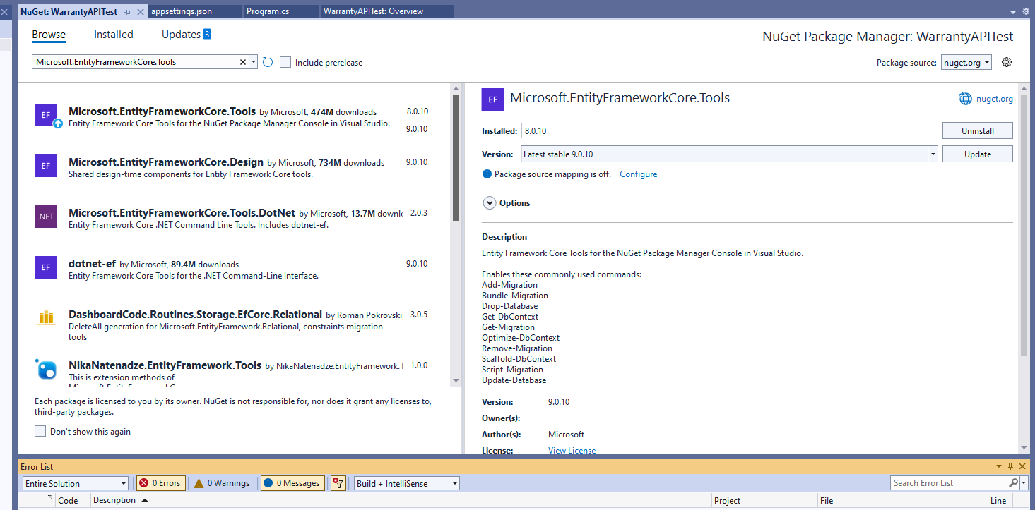

GET

GET BY ID

POST

PUT

PATCH (replace,remove)

DELETE

Validations

using System.ComponentModel.DataAnnotations;

[Required]

public string PartNumber { get; set; }

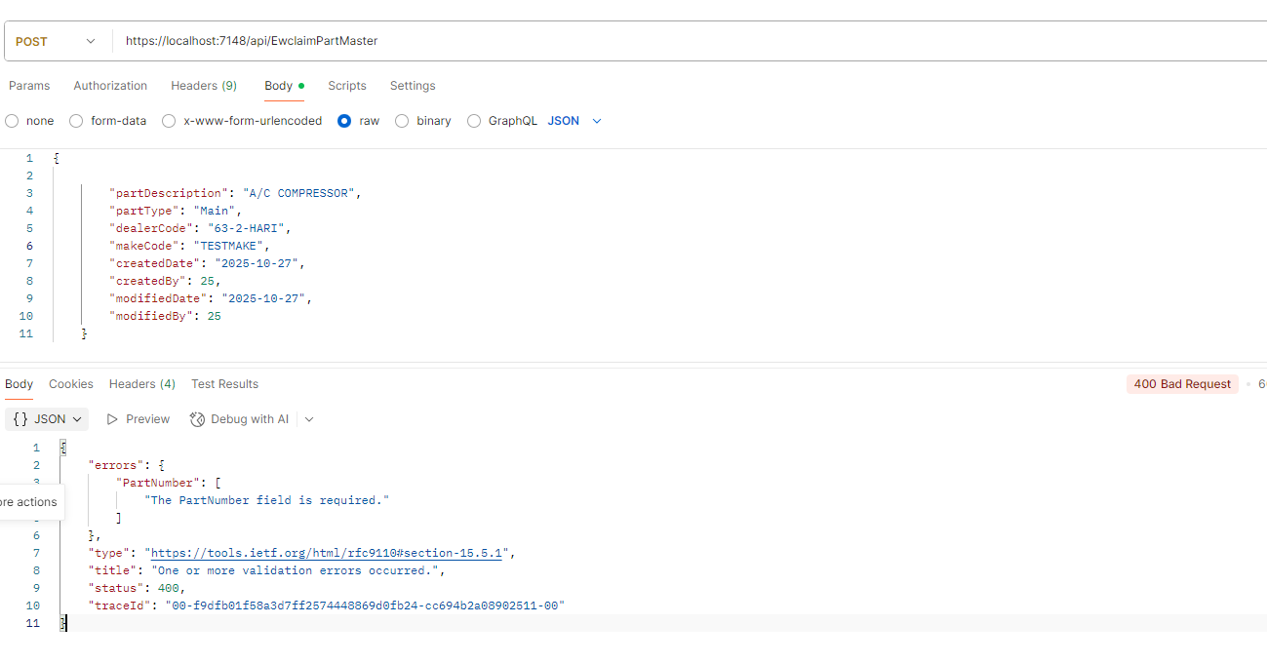

using Microsoft.AspNetCore.JsonPatch;

using WarrantyAPITest.Models;

namespace WarrantyAPITest.Interfaces

{

public interface IEwclaimPartMasterRepository

{

Task<List<EwclaimPartMaster>> GetAllAsync();

Task<EwclaimPartMaster?> GetByIdAsync(int _partnumber);

Task<int> AddAsync(EwclaimPartMaster _EwclaimPartMasterModel);

Task UpdateAsync(int PartID, EwclaimPartMaster _part);

Task DeleteAsync(int Partid);

Task UpdatePatchAsync(int partid, JsonPatchDocument _EwclaimPartMaster);

}

}

using Azure;

using Microsoft.AspNetCore.Http.HttpResults;

using Microsoft.EntityFrameworkCore;

using Microsoft.AspNetCore.JsonPatch;

using System.Diagnostics.Eventing.Reader;

using WarrantyAPITest.Data;

using WarrantyAPITest.Interfaces;

using WarrantyAPITest.Models;

using JsonPatchDocument = Microsoft.AspNetCore.JsonPatch.JsonPatchDocument;

namespace WarrantyAPITest.Repository

{

public class EwclaimPartMasterRepository : IEwclaimPartMasterRepository

{

private readonly GaponlineDemo1Context _context;

public EwclaimPartMasterRepository(GaponlineDemo1Context context)

{

_context = context;

}

public async Task<List<EwclaimPartMaster>> GetAllAsync()

{

//throw new NotImplementedException();

var records = await _context.EwclaimPartMasters.Select(x=> new EwclaimPartMaster()

{

PartId=x.PartId,

PartNumber =x.PartNumber,

PartDescription = x.PartDescription,

PartType = x.PartType,

DealerCode = x.DealerCode,

MakeCode = x.PartNumber,

CreatedDate = x.CreatedDate,

CreatedBy = x.CreatedBy,

ModifiedDate = x.ModifiedDate,

ModifiedBy = x.ModifiedBy

}

).ToListAsync();

return records;

}

//public async Task<IEnumerable<EwclaimPartMaster>> GetAllAsync()

//{

// //throw new NotImplementedException();

// var records= await _context.EwclaimPartMasters.ToListAsync();

//}

public async Task<EwclaimPartMaster?> GetByIdAsync(int _partnumber)

{

//throw new NotImplementedException();

var records = await _context.EwclaimPartMasters.Where(x => x.PartId == _partnumber).Select(x => new EwclaimPartMaster()

{

PartId = x.PartId,

PartNumber = x.PartNumber,

PartDescription = x.PartDescription,

PartType = x.PartType,

DealerCode = x.DealerCode,

MakeCode = x.PartNumber,

CreatedDate = x.CreatedDate,

CreatedBy = x.CreatedBy,

ModifiedDate = x.ModifiedDate,

ModifiedBy = x.ModifiedBy

}

).FirstOrDefaultAsync();

return records;

}

public async Task<int> AddAsync(EwclaimPartMaster _EwclaimPartMasterModel)

{

//throw new NotImplementedException();

var _EwclaimPartMaster = new EwclaimPartMaster()

{

PartNumber = _EwclaimPartMasterModel.PartNumber,

PartDescription = _EwclaimPartMasterModel.PartDescription,

PartType = _EwclaimPartMasterModel.PartType,

DealerCode = _EwclaimPartMasterModel.DealerCode,

MakeCode = _EwclaimPartMasterModel.PartNumber,

CreatedDate = _EwclaimPartMasterModel.CreatedDate,

CreatedBy = _EwclaimPartMasterModel.CreatedBy,

ModifiedDate = _EwclaimPartMasterModel.ModifiedDate,

ModifiedBy = _EwclaimPartMasterModel.ModifiedBy

};

_context.EwclaimPartMasters.Add(_EwclaimPartMaster);

await _context.SaveChangesAsync();

return _EwclaimPartMaster.PartId;

}

//public Task UpdateAsync(int partID)

//{

// // throw new NotImplementedException();

// EwclaimPartMaster _EwclaimPartMaster = GetByIdAsync(partID);

//}

public async Task UpdateAsync( int PartID, EwclaimPartMaster _EwclaimPartMasterModel)

{

/*

//Method 1 (2 db works : 1 - fetch ;2- update)

var existPartMaster= await _context.EwclaimPartMasters.FindAsync(PartID);

if (existPartMaster != null) {

existPartMaster.PartId = _EwclaimPartMasterModel.PartId;

existPartMaster.PartNumber = _EwclaimPartMasterModel.PartNumber;

existPartMaster.PartDescription = _EwclaimPartMasterModel.PartDescription;

existPartMaster.PartType = _EwclaimPartMasterModel.PartType;

existPartMaster.DealerCode = _EwclaimPartMasterModel.DealerCode;

existPartMaster.MakeCode = _EwclaimPartMasterModel.MakeCode;

existPartMaster.CreatedDate = _EwclaimPartMasterModel.CreatedDate;

existPartMaster.CreatedBy = _EwclaimPartMasterModel.CreatedBy;

existPartMaster.ModifiedDate = _EwclaimPartMasterModel.ModifiedDate;

existPartMaster.ModifiedBy = _EwclaimPartMasterModel.ModifiedBy;

await _context.SaveChangesAsync();

}

*/

//Method 2 (1 db works : 1- update)

var _EwclaimPartMaster = new EwclaimPartMaster()

{

PartId= PartID,

PartNumber = _EwclaimPartMasterModel.PartNumber,

PartDescription = _EwclaimPartMasterModel.PartDescription,

PartType = _EwclaimPartMasterModel.PartType,

DealerCode = _EwclaimPartMasterModel.DealerCode,

MakeCode = _EwclaimPartMasterModel.MakeCode,

CreatedDate = _EwclaimPartMasterModel.CreatedDate,

CreatedBy = _EwclaimPartMasterModel.CreatedBy,

ModifiedDate = _EwclaimPartMasterModel.ModifiedDate,

ModifiedBy = _EwclaimPartMasterModel.ModifiedBy

};

_context.EwclaimPartMasters.Update(_EwclaimPartMaster);

await _context.SaveChangesAsync();

}

public async Task UpdatePatchAsync(int partId, JsonPatchDocument _EwclaimPartMaster) {

var existPartMaster = await _context.EwclaimPartMasters.FindAsync(partId);

if (existPartMaster != null) {

_EwclaimPartMaster.ApplyTo(existPartMaster);

await _context.SaveChangesAsync();

}

}

public async Task DeleteAsync(int Partid) {

var existPartMaster = new EwclaimPartMaster() { PartId = Partid };

_context.EwclaimPartMasters.Remove(existPartMaster);

await _context.SaveChangesAsync();

}

}

}

using System;

using System.Collections.Generic;

using System.ComponentModel.DataAnnotations;

namespace WarrantyAPITest.Models;

public partial class EwclaimPartMaster

{

public int PartId { get; set; }

[Required]

public string PartNumber { get; set; }

public string? PartDescription { get; set; }

public string? PartType { get; set; }

public string? DealerCode { get; set; }

public string? MakeCode { get; set; }

public DateTime? CreatedDate { get; set; }

public short? CreatedBy { get; set; }

public DateTime? ModifiedDate { get; set; }

public short? ModifiedBy { get; set; }

}

using Microsoft.AspNetCore.Http;

using Microsoft.AspNetCore.JsonPatch;

using Microsoft.AspNetCore.Mvc;

using Microsoft.EntityFrameworkCore;

using WarrantyAPITest.Data;

using WarrantyAPITest.Interfaces;

using WarrantyAPITest.Models;

namespace WarrantyAPITest.Controllers

{

[Route("api/[controller]")]

[ApiController]

public class EwclaimPartMasterController: ControllerBase

{

private readonly IEwclaimPartMasterRepository _IEwclaimPartMasterRepository;

public EwclaimPartMasterController(IEwclaimPartMasterRepository objIEwclaimPartMasterRepository)

{

_IEwclaimPartMasterRepository = objIEwclaimPartMasterRepository;

}

[HttpGet("")]

public async Task<ActionResult> GetAllParts() {

var parts=await _IEwclaimPartMasterRepository.GetAllAsync();

return Ok(parts);

}

[HttpGet("{partnum}")]

public async Task<ActionResult> GetPartsByID([FromRoute] int partnum)

{

var ewclaimPartMasters = await _IEwclaimPartMasterRepository.GetByIdAsync(partnum);

return Ok(ewclaimPartMasters);

}

//public async Task<ActionResult> GetPartsByID([FromRoute]string partnum)

//{

// var ewclaimPartMasters = await _IEwclaimPartMasterRepository.GetByIdAsync(partnum);

// return Ok(ewclaimPartMasters);

//}

[HttpPost("")]

public async Task<ActionResult> AddNewPart([FromBody] EwclaimPartMaster _part)

{

var partNo = await _IEwclaimPartMasterRepository.AddAsync(_part);

return CreatedAtAction(nameof(GetPartsByID),new { partnum = partNo ,Controller= "EwclaimPartMaster" },partNo );

// return CreatedAtAction(nameof(GetPartsByID), new { partnum = partNo, Controller = "EwclaimPartMaster" }, _part);

}

[HttpPut("{partid}")]

public async Task<ActionResult> UpdateNewPart([FromRoute] int partid, [FromBody] EwclaimPartMaster _part)

{

await _IEwclaimPartMasterRepository.UpdateAsync(partid, _part);

return Ok();

}

[HttpPatch("{partid}")]

public async Task<ActionResult> UpdateNewPartPatch([FromRoute] int partid, [FromBody] JsonPatchDocument _part)

{

await _IEwclaimPartMasterRepository.UpdatePatchAsync(partid, _part);

return Ok();

}

[HttpDelete("{partid}")]

public async Task<ActionResult> DeletePart([FromRoute] int partid)

{

await _IEwclaimPartMasterRepository.DeleteAsync(partid);

return Ok();

}

}

}